CLOUD SERVICES AGREEMENT (CSA)
Commencement Date and Duration
This Cloud Services Agreement (“CSA”) shall commence on the date the Customer first accesses, registers for, or uses the Cloud Services via the Provider’s online portal (the “Effective Date”) and shall remain in effect until terminated in accordance with this CSA.
Access to or use of the Cloud Services constitutes the Customer’s irrevocable acceptance of this CSA. No physical or electronic signature is required, and the Customer waives any right to claim non-acceptance based on the absence of manual execution.
This CSA supersedes all prior or contemporaneous agreements relating to the same or similar services. As of the Effective Date, any such agreements are automatically terminated and shall have no further force or effect.
Service Description
1CNG offers virtualized server resources within a robust and secure environment, providing customers with flexibility, scalability, and control over their hosting needs. With dedicated resources and customizable configurations, our solutions are ideal for businesses and individuals requiring services.
Scalability: Easily scale up resources based on changing demands, allowing for seamless expansion as your business grows.
Customization: Choose from various operating systems, and software configurations to tailor the specific requirements.
Network Connectivity: Robust network connectivity with high-speed internet access and low-latency connections. Bandwidth allocation based on chosen the service plan, with options for metered or unmetered bandwidth.
Guaranteed Speed: Minimum guaranteed bandwidth of 100 Mbps.
Latency Levels: The cloud infrastructure ensures an average latency of <25ms within the local region and <50ms for international connections, depending on the geographical location of the user.
Datacenter Tier Classification: Our datacenters are certified as Tier 3 according to the Uptime Institute's Tier Classification System, which signifies high availability and redundancy in infrastructure design.
- High-Speed Fiber Connectivity: Our datacenters are interconnected via high-speed fiber optic links to ensure low-latency and high-bandwidth connectivity with multiple ISP providers (exceeding a minimum of three providers).
In the event of a fiber route failure, traffic can be rerouted within a few seconds as a highly resilient network architecture interconnects sites through multiple redundant pathways, ensuring continuous availability and fault tolerance in the event of link degradation or failure. While minimal latency may occur during the transition, our redundant network design ensures uninterrupted connectivity.
- Redundant Fiber Routes: We maintain redundant fiber routes between datacenters to minimize the risk of connectivity disruptions and ensure data transmission reliability.
- Bandwidth Allocation: Fiber links provide ample bandwidth for data replication, backup transfers, and DR failover operations without performance bottlenecks.
- High Availability: Compute hosts are deployed in a clustered configuration with N+1 or higher redundancy and Automatic VM failover is enabled for physical host failures and hypervisor failures.
- Fault Tolerance: The compute infrastructure is designed with no single point of failure including redundant power supply, network paths, compute, cluster-aware workload.
- Data Protection & Availability: Regular backups are performed for all service virtual machines to ensure data protection and enable service restoration in the event of failures or incidents.

Support: Utilize redundant infrastructure, backup solutions, and 24/7 monitoring to maintain high availability and uptime for your services.

Payment Terms
Currency: All payments will be processed in Myanmar currency (MMK).
Prepaid Payment Terms
Customers have to maintain sufficient Infra Credit Balance to create or renew any services. Usage amount is deducted from the infra credit amount. If there is not enough balance, the system will not allow the service to be created.

Service Creation
- If the infra credit has sufficient balance, CMP allows the creation of a service.
- If the wallet does not have sufficient balance, CMP does not allow the creation of a service.
Service Renewal
- If the infra credit has sufficient balance, CMP automatically renews the service.
- If the infra credit does not have sufficient balance, CMP generates an invoice, marks it as unpaid, and the wallet balance goes into negative.
- Renewal invoices are always generated in advance except for hourly.
Infra Credit Balance Management
- Adding funds to the wallet is a manual process.
- There is no automated card charging or recurring top-up mechanism.
Prepaid Invoice generation
In the prepaid model, it is an infra credit-based system, the actual money transaction happens when the customer adds infra credit balance. To support different legal requirements, the system provides two models:
Receipt for wallet transactions and invoice for services
- The system issues a receipt when Infra Credits are purchased.
- The system generates invoices for each service usage or renewal.
Billing Cycles Options
Our platform provides flexible billing cycles to meet different customer needs:

1.Hourly Billing Cycle (Pay-as-you-go):
Customers are charged based on actual hourly usage of resources. This model offers maximum flexibility and is ideal for short-term or unpredictable workloads. All hourly usage during the month is collected and included in a single monthly invoice and are generated on the 1st of the following month.
2.Monthly Billing Cycle:
Customers can subscribe to services on a monthly basis. This option provides predictable costs and is suitable for workloads that require consistent usage throughout the month. The invoice is generated immediately upon service creation.

3.Yearly Billing Cycle (Reserved Instance – Pay Less, Use More):
Customers who commit to a one-year subscription benefit from significantly reduced rates compared to hourly or monthly billing. This model is designed for long-term, stable workloads where cost efficiency is a priority. The invoice is generated at the time of service creation, and the discounted rate applies for the full duration of the commitment.

Service Level Agreement (SLA)
Service Description: The Service Level Agreement (SLA) governs the provision of cloud services by 1CNG. It includes a detailed description of the services being offered, such as cloud infrastructure, software applications, or data storage solutions. The SLA will specify the features and functionalities of the services, ensuring clarity and understanding between the 1CNG and the Customer.
SLA Times
Priority Level | Description | Typical Scenarios | Response Time | Resolution Time | Root Cause Analysis
Critical | Full service disruption. Affects all customers or core systems. No workaround. | Cloud platform fully down, VM access or APIs unreachable, Major infrastructure failure | within 2 hours | within 4 hours | within 24 hours
High Priority | Major functionality disrupted. Affects many users. Partial workaround possible. | Partial network or storage outage | within 2 hours | within 8 hours | within 24 hours
Medium Priority | Limited issue with moderate impact. Affects few users or non-core features. Workaround available. | Performance degradation for some users | within 2 hours | within 24 hours | within 72 hours
Low Priority | Minor issue. No impact on operations. Cosmetic or informational. | Suggestions for improvement | within 2 hours | within 72 hours | within 72 hours

1CNG guarantees rapid response times for critical issues, with a commitment to respond within 2 hours.
The format for the Root Cause Analysis shall be determined by the Customer and provided to 1CNG.

Uptime Guarantee Period (Monthly)
 | Response Time
Monthly Uptime | 99.95% uptime
1CNG commits to a 99.95% uptime for its Cloud services, excluding the exceptions listed in “Exclusions” section).
Uptime Commitment: 1CNG strives to provide monthly 99.95% uptime for each individual instance. However, we do not guarantee uninterrupted service due to factors beyond our control (natural disasters, cyber-attacks, etc.). Uptime is defined as the availability of the Cloud to process data requests and maintain connectivity with external networks.

Downtime Compensation (Monthly)
Instance-Level Uptime | Service credits
Less than 99.95% but equal to or greater than 99% | 10%
Less than 99% but equal to or greater than 95% | 30%
Less than 95% | 100%

Service credits are calculated as a percentage of the total monthly service usage hours for the services and will be issued as additional usage hours, which shall be discounted on the next invoice automatically.
If 1CNG fails to meet the monthly 99.95% uptime guarantee, Customer is eligible for service credits for the services offered under this SLA. Downtime is measured as the total number of minutes the service remains unavailable below 99.95% uptime within a given month, except for circumstances listed in “Exclusions” section. Downtime is monitored and recorded by 1CNG’s internal tracking systems.
Maintenance: Scheduled maintenance will be communicated in advance whenever possible and no less than 48 (forty-eight hours). Emergency maintenance may occur without prior notice if necessary to protect the infrastructure and shall be considered as downtime, except for circumstances listed in “Exclusions”.

Termination and Suspension
This CSA is valid for the order which this CSA accompanies.
Prepaid: Disciplinary action is applied after the set number of grace days from the time the account goes negative.
Notification: A disciplinary action reminder notification will be sent 24 hours in advance to the Customer indicating the outstanding payment and the impending service disruption.
The freeze action is applied 1 days after the time the account goes negative (prepaid).
Example: If an account balance goes negative on the 15th of the month and the freeze action will start on 16th of the month. And the Freeze Action period is 7 days.
When an account is frozen:
  - Customers can still access all their existing services.
  - Customers cannot create new paid services.
  - Customers cannot make changes or perform actions on existing services.
In short, service creation and modifications are restricted, but access remains available.

Service Disruption (After 7 Days)
The suspend action is applied after the 7-day grace period from the time an account was frozen.
Example: If an account was frozen on the 15th of the month and the suspension grace period is 7 days, then the suspension action will be applied on the 22nd of the month.
When an account is suspended: During the suspension period, customers may have limited or no access to their resources, data, and services. Customers cannot create new services. Only the Billing module remains accessible so that payments can be made.
In short: When suspended, the customer can only log in to pay their dues.

Termination Process (After 30 Days)
The suspend action is applied after the 14 days from the time an account was suspended.

Example: If an account was suspended on the 15th of the month and the termination grace period is 14 days, then the termination action will be applied on the 29th of the month.

Account Closure: On the termination date, the customer's account will be closed, and all data associated with the service will be permanently deleted.
Loss of Access: After termination, the customer will loose access to all resources, configurations, and data stored on the server.
Termination of this CSA shall be available to any party immediately in the event that any of the following conditions occurs:-
- Breach of the conditions of Cloud Services Agreement, Service Level Agreement and Terms & Conditions of 1CNG: (or)
- Occurrence of force majeure over six (6) months: (or)
- Incapability of implementing the original aims of the agreement by changing the government policies.
Data Backup and Retrieval
Backup Options: Customers are encouraged to back up their data before the termination date (7 days) to avoid data loss.
Reactivation and Reinstatement
Payment Settlement: If payment is received after service suspension but before termination, services will be reinstated upon payment confirmation.
Account Closure and Communication
Closure Notification: A final notification will be sent to the customer upon account closure, confirming the termination of services and the closure of the user account through email.

User Responsibilities & Responsibilities Matrix
User Responsibilities
Use of Services: Customer shall only use the Cloud for lawful purposes and in accordance with this CSA. Customer is responsible for any data, content, or software installed or operated on the Cloud.
Security: Secure your Cloud and account by implementing appropriate measures (strong passwords, security patches, etc.). 1CNG is not liable for any security breaches caused by the User's failure to use the services in accordance with Terms and Conditions listed under this CSA. 1CNG shall maintain security protocols and quality according to the market standards.
Prohibited Activities: You may not engage in illegal activities, including but not limited to:
- Hosting, storing, or transmitting unlawful, fraudulent, or malicious content
- Sending spam emails or initiating distributed denial-of-service (DDoS) attacks
- Hosting pirated software or copyright-infringing content
- Using the Cloud for unauthorized cryptocurrency mining
- Any activity that harms or disrupts 1CNG’s network or infrastructure
Copyrighted Content: Users must not upload, store, share, or distribute copyrighted material without proper authorization or licensing from the copyright owner. This includes text, images, videos, software, and other digital content.
Government and Political Content: Users must not engage in activities that violate government regulations, laws, or political restrictions related to content dissemination, censorship, or expression. This includes content that incites violence, promotes hate speech, or violates human rights.

Responsibilities Matrix

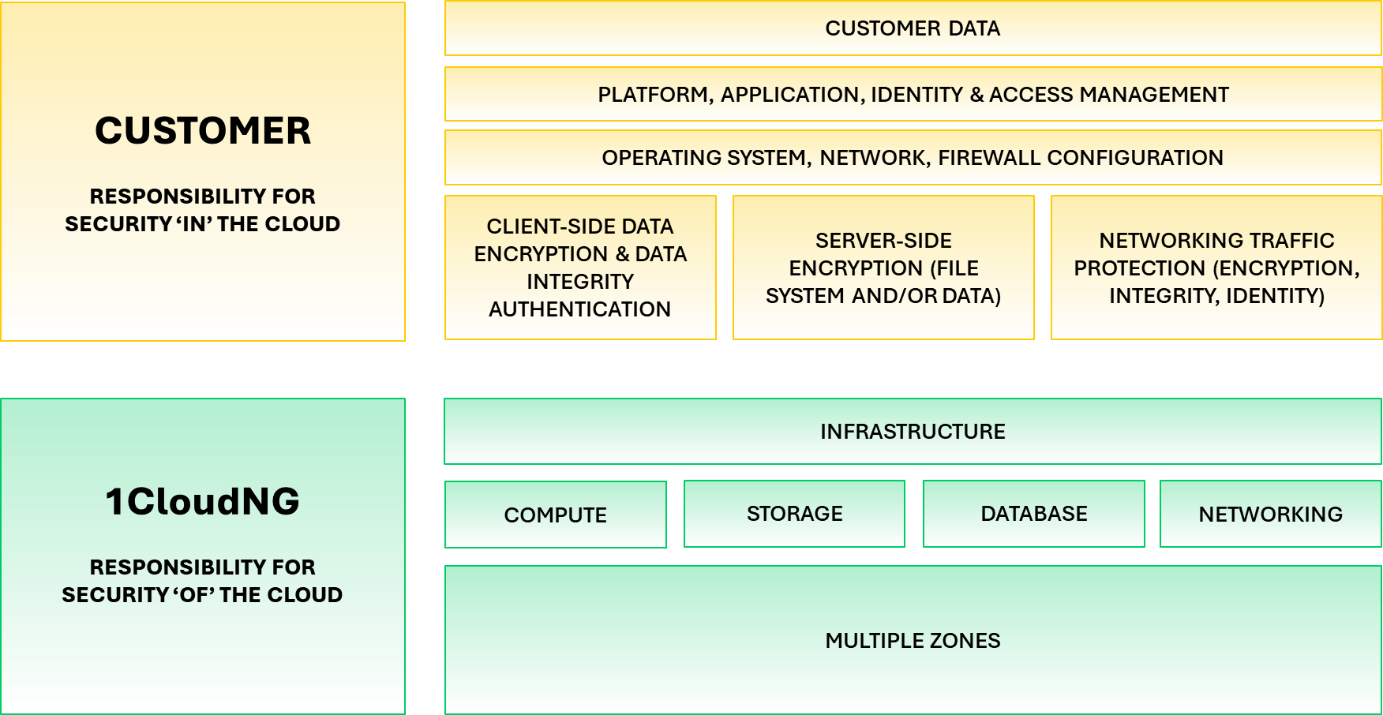

Data Privacy and Security
Data Protection: While 1CNG does not access or manage the data stored on your Cloud, we take measures to protect the underlying infrastructure from unauthorized access.
User Responsibility: You are responsible for securing your own data and maintaining compliance with applicable privacy and data protection laws. 1CNG is not liable for data breaches caused by User's configuration or usage.

Exclusions
The below situations are excluded from the 99.95% uptime guarantee, and downtime occurring in these circumstances will not qualify for service credits:

Scheduled Maintenance
Regular maintenance, which is necessary for updates and improvements to the Cloud infrastructure, will be communicated within at least 48 (forty-eight) hours in advance during off-peak hours whenever possible to minimize the impact on customers' VMs. Such maintenance windows are not considered downtime for SLA purposes.
If the scheduled maintenance window exceeds the communicated period, it will be considered downtime for SLA purposes.

Customer-Caused Issues
Service disruptions caused by any of the following are not covered by this SLA:
Misconfigurations or errors caused by the customer’s software or settings.

Misuse of resources, security breaches due to weak passwords, or improper management by the customer.
Any actions performed by the customer that are prohibited under this CSA (e.g., applying unsafe updates or custom configurations).

Force Majeure
1CNG is not responsible for service disruptions caused by events beyond our control, including but not limited to:
- Natural disasters (e.g., earthquakes, floods, storms, etc.,)
- Acts of war, acts of public enemies, riot, civil war, terrorism, or civil unrest, blockade
- Power outages, governmental actions, or regulations
- Internet-wide issues, including failures in networks, or global routing infrastructure
- Cyber-attack (hacking and DDOS)
- Issues related to third-party software, services, or providers outside 1CNG’s control do not qualify for SLA claims.

Miscellaneous
In the event of any conflict between this CSA and any other agreement, document, policy, or terms referenced herein or made available through the Provider’s portal, this CSA shall prevail.
This CSA shall be governed by and constructed in accordance with the laws of the Republic of the Union of Myanmar. Any dispute arising out of or in connection with this CSA shall be subject to the exclusive jurisdiction of the competent courts of the Republic of the Union of Myanmar.
Access to or use of the Cloud Services constitutes the Customer’s irrevocable acceptance of this CSA and all applicable laws, regulations, policies, and terms of service. No physical or electronic signature is required.
The Customer shall be solely responsible for any breach of this CSA or applicable laws and shall indemnify and hold the Provider harmless from all costs, liabilities, damages, penalties, fines, and legal fees arising from such breach.

